Database Systems
  - Quiz 02 – Fall 2024

Question 1
Apply normalization to the following scenarios.
- Determine if this relation is in 1NF. If not, then convert it into 1NF.

- Determine if this relation is in 2NF. If not, then convert it into 2NF.
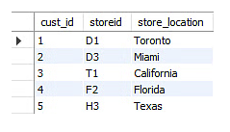
The Location table possesses a composite primary key cust_id, storeid. The non-key attribute is store_location.

- Determine if this relation is in 3NF. If not, then convert it into 3NF.
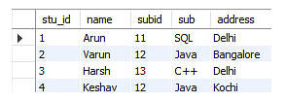
stu_id determines subid
subid determines sub

